Scenario of teaching video ‘ Camera ubiquity’

#1 A general drama.
A drama is in progress with a general cut rate. (fig.1.1～1.3)
N (narration) "This is one scene of a drama describing the scenery of an everyday table that you have seen now. What work has been done during its production?”
Director's voice "Cut!"
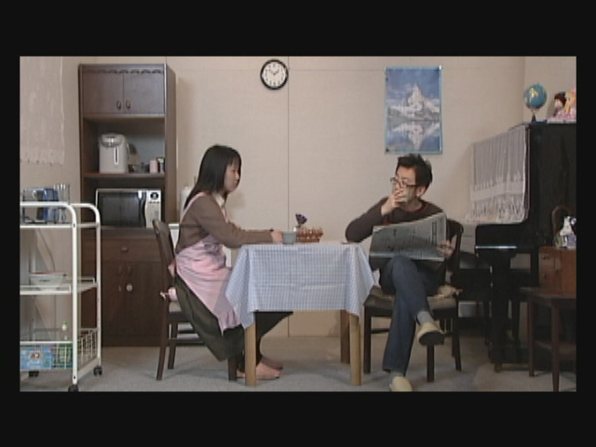 | 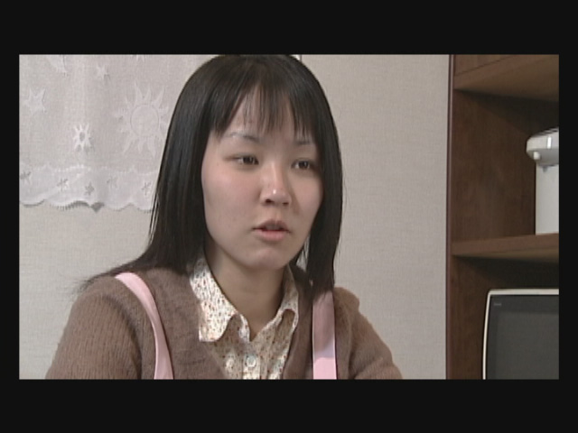 | 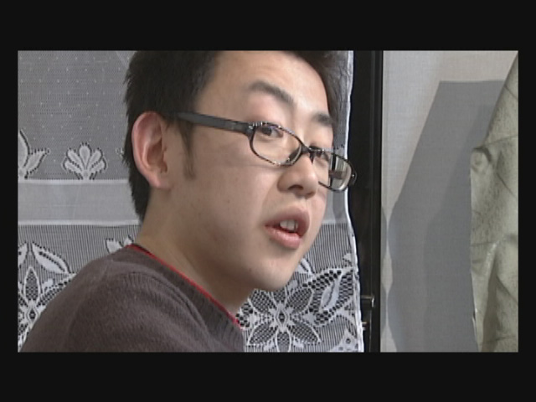
fig.1.1 | fig.1.2 | fig.1.3

#2 Scenery of filming in a studio.
This is a scenery of filming in a studio. Staff and casts are doing their work. (fig.2.1)
Director “OK! This cut is good. Well, lets go to film from this change. Bring the
camera here, please.”
Camera “OK, camera will be moved.”
Assistant “OK, camera will be moved.”
Camera is moved and set. (fig.2.2)
Director “Well, lets go to the next cut.”
Co-Director “OK, scene 5, cut 8, take 1.”
Director “Prepare.”
Camera “Camera is working.”
Director “Start.”
A cast is playing.
N “A scene is a part of a film or a drama that is continuously describing one situation. One scene is divided into some cuts and filmed in these portions.”
Director “Cut. OK. Please move the camera here for the next cut.”
Co-Director “Scene 5, cut 9, take 1.”
Director “Prepare, start.”
A cast is playing. (fig.2.3)
N “One cut is a passage recorded between the moment when recording button of a camera is pushed and a moment when is pushed later again. Recorded cuts are edited and then merged into one scene.”
Director “Cut.”
Co-Director “OK, cut.”
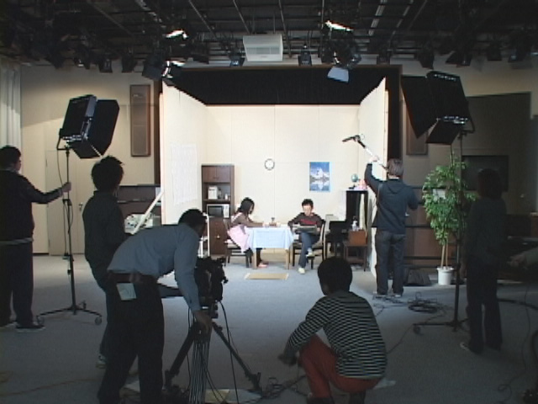 | 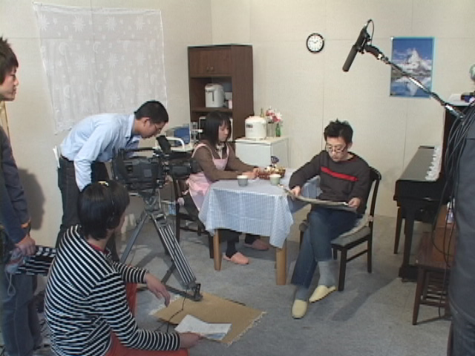 | 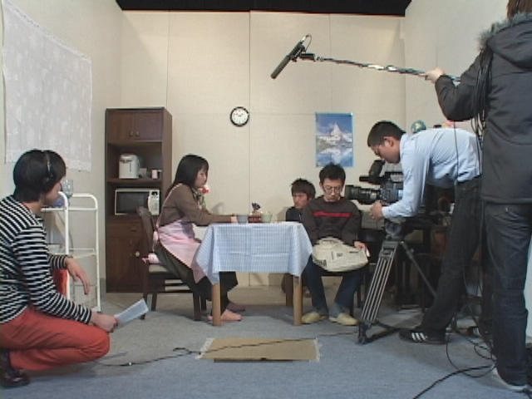
fig.2.1 | fig.2.2 | fig.2.3

#3 Man and woman's cut changes.
A drama produced with a general cut rate. Same as #1 (continuing)
N “Audio-visual expression made in this way is natural, and accepted by spectators. But, if you try to think about where is camera during each of the cuts, sometimes you will recognize that strange things happen.
For example in this cut, a woman is filmed instead of a man who was filmed previously. Where is camera at this time?”
N “The position of the camera which was taking this cut was almost in the front of the woman. However, if a camera is in this place all the time, it must be seen after the change of filming direction when a man is being filmed instead of the woman. (fig.3.1)
Again, if the woman is being filmed instead of a man, camera standing next to her must be seen.”
N “However, in fact, camera is replaced during a cut change, and therefore can not be seen in the place where was expect to be. (fig.3.2)
In a complete film, a camera can be freely moved without being seen.
In a film, a camera can exist everywhere. This is called ‘camera ubiquity’.”

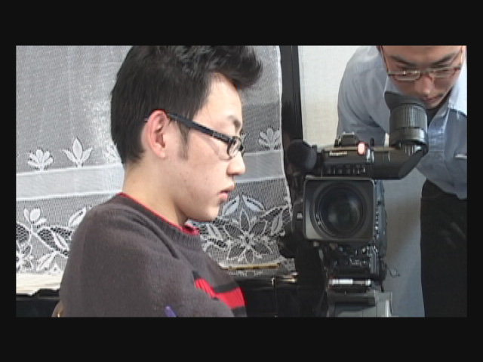 | 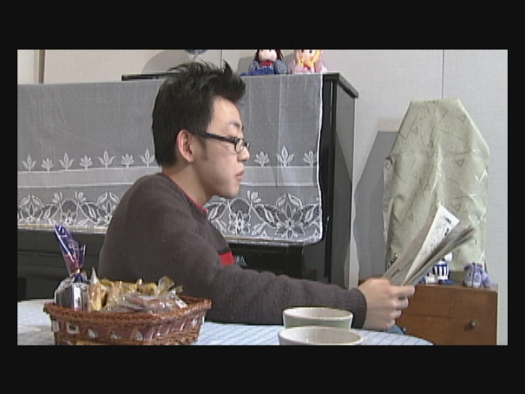
fig.3.1 | fig.3.2

#4 Title ‘Camera ubiquity.

#5 Filming without changing position of a camera.
Stage-like filming.
N “In the initial days of a film, the position of a camera was fixed as the stage of play was seen from spectators’ seats. Camera did not move, but the actors did move before the camera. The sizes of persons in a film taken were same. ” (fig.5.1～5.3)
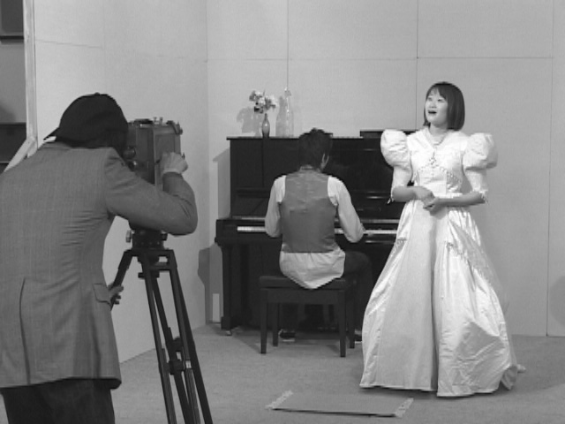 | 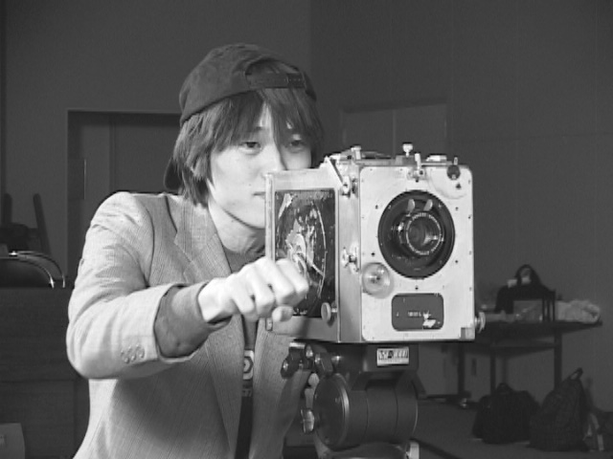 | 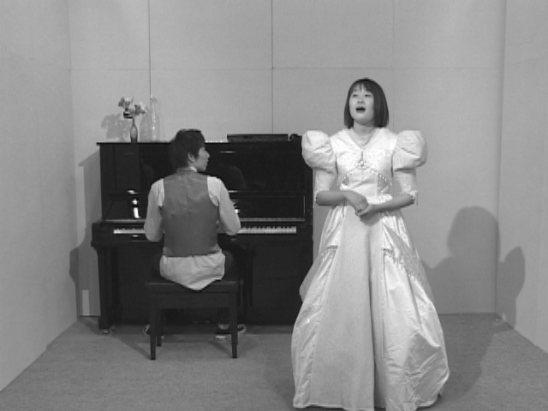
fig.5.1 | fig.5.2 | fig.5.3

#6 Filming outdoors – a man and tow robbers.
Filming outdoors – a scene of a man having a rest by the roadside. Two robbers draw near to him and try to steal his baggage.
N “The development of film expression enabled to choose a camera position that makes the spectators involved in the story.
In this scene, a man is sitting by the roadside. Suddenly, two robbers appear and try to do him something bad. An accumulation of such cuts makes the position of a man and thief, as well as the situation in the story easy to be understood. ” (fig.6.1～6.3)

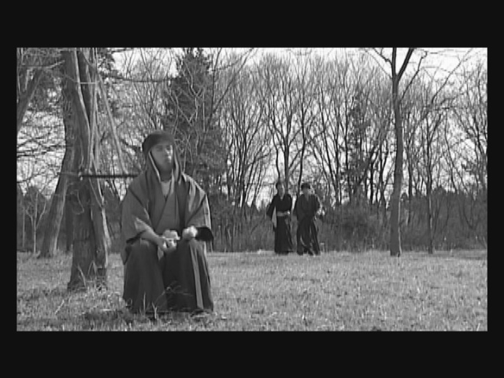 | 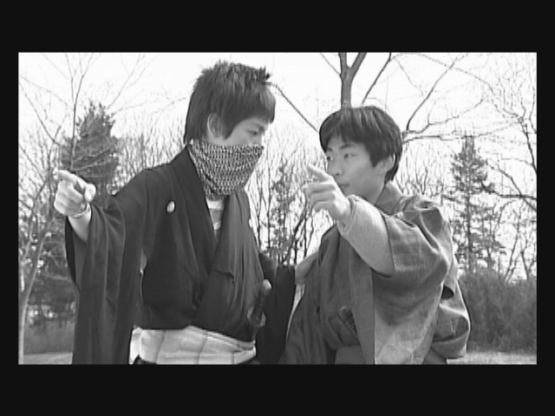 | 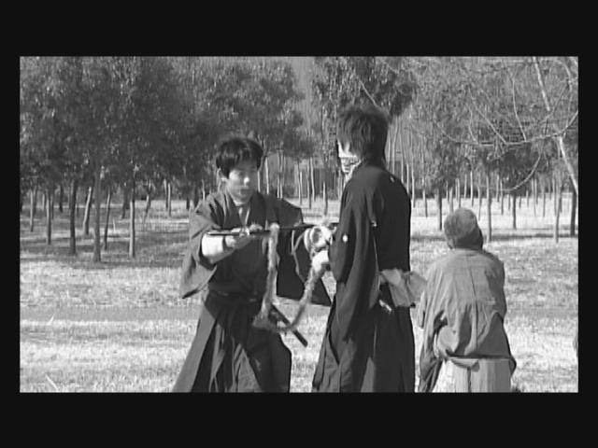
fig.6.1 | fig.6.2 | fig.6.3

N “Each of the cuts is filmed using free camera positioning. Of course, a camera cannot be seen in any cut. Camera can exist everywhere and also does not exist anywhere. But, if such cuts are edited and merged, spectators can easily understand a film story. Camera ubiquity is important principle forming film expression.” (fig.6.4)
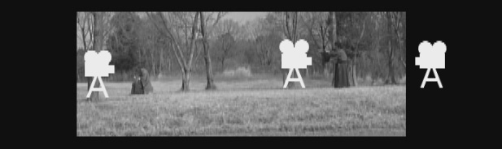
fig.6.4

#7 Overcoming of physical limitations.
Film scene of a space with walls in four sides.
N “According to the principle of camera ubiquity, a camera can exist in a space overcoming physical limitations. If we try to film a conversation in this room, and place the camera in the space within the room, the composition that can be filmed is very limited.” (fig.7.1)
The situation of a camera being placed outside the set. (fig.7.2)
N “However, if one of the set walls can be removed, and the camera can be placed in the space outside this room, the whole room can be caught in one screen, and the positions of persons can be clearly demonstrated.” (fig.7.3)

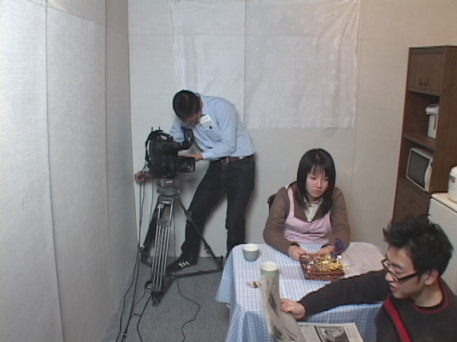 | 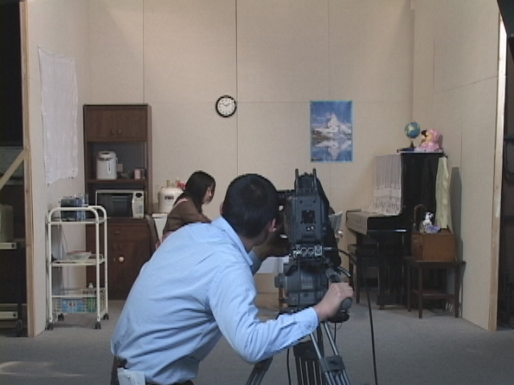 | 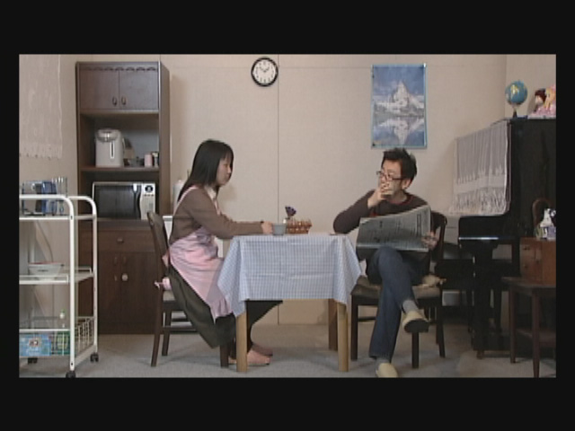
fig.7.1 | fig.7.2 | fig.7.3

#8 Presence of a performer alone.
A scene of a drama.
N “In this scene, the story seems to be developed with only a married couple present in the room.” (fig.8.1)
A scene of a studio.
N “In a real studio, not only performers but also a cameraman as well as staff are present in the room.” (fig.8.2)
A scene of a drama.
N “However, in the final film only these two people are present in the room. Such way of expression can be said to be a film convention.”
A film spectator does not know about such convention. But, such film expression is accepted in a natural way.
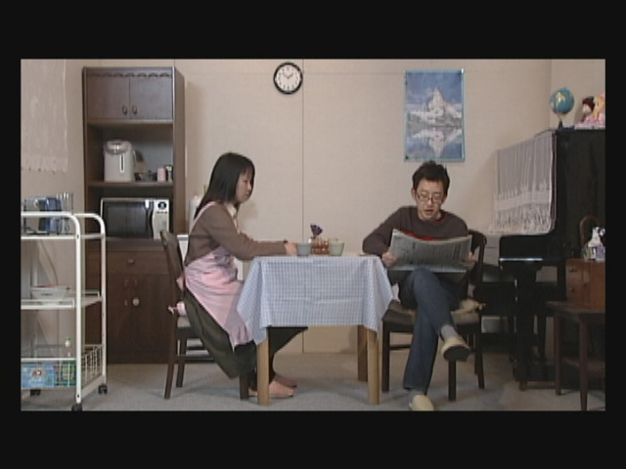 | 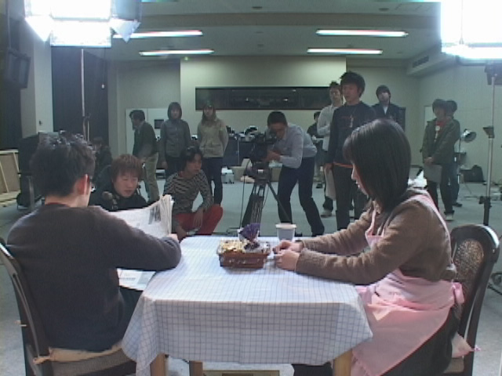
fig.8.1 | fig.8.2

#9 Filming from one direction.
A scene of a drama – a scene of filming on a stage.
N “Lets try to do an experiment to test whether the application of a camera ubiquity principle can lead to appropriate audio-visual expression.
Firstly, we use fixed camera position to film from just one direction as we are looking at the stage. What is the story the spectator can imagine from such expression?”
N “If the camera position is still the same, and a woman is taken from behind, her expression as well as action are difficult to be understood.” (fig.9.1～9.3)
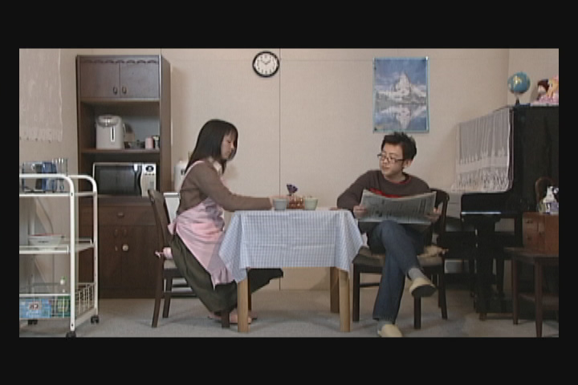 | 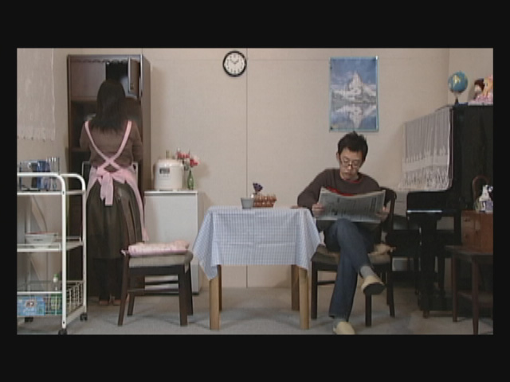 | 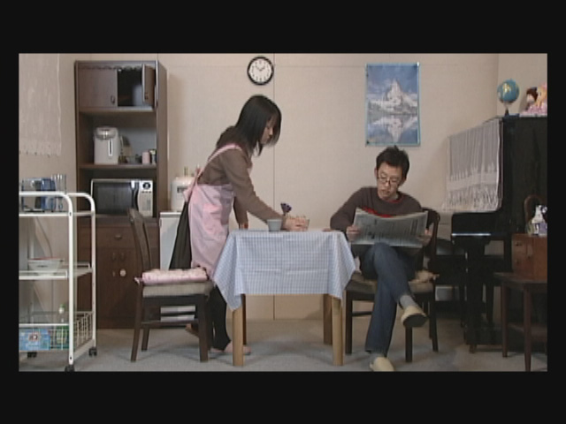
fig.9.1 | fig.9.2 | fig.9.3

#10 Camera in a cabinet.
A scene of a drama taken from a cabinet.
N “Here we try to radically change the camera position to film a cut in that woman’s expression is caught from the front of her. The spectators can recognize a new development of the story.” (fig.10.1～10.3)
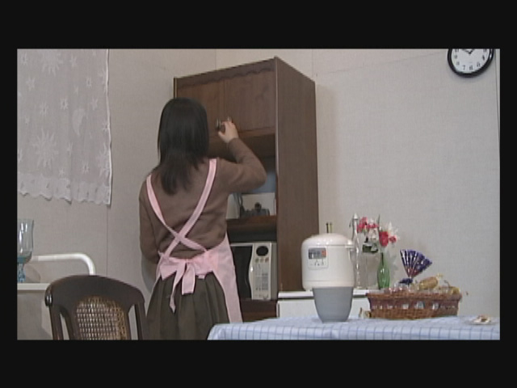 | 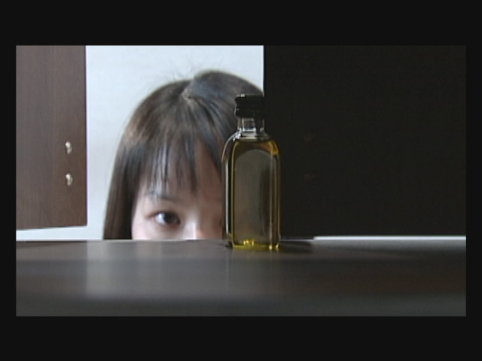 | 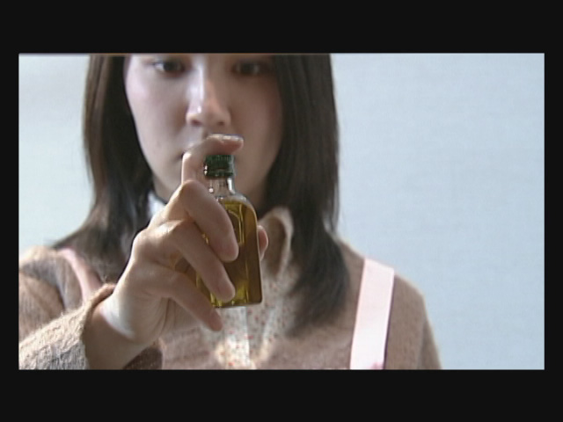
fig.10.1 | fig.10.2 | fig.10.3

A scene of a studio – back part of a cabinet is being removed
N “It is impossible to put a big camera into the cabinet. Instead of this, the back part of the cabinet is removed, and the scene is filmed from the side behind of the cabinet.
The cabinet is moved forward and a place for camera is created.
If the scene was filmed from this place, it would be clear, that there was not created any wall in the background of the woman.” (fig.10.4)
N “Therefore, if a new wall is created and filmed just behind the woman, it will seem, as the conversation is performed in one room.” (fig.10.5&10.6)
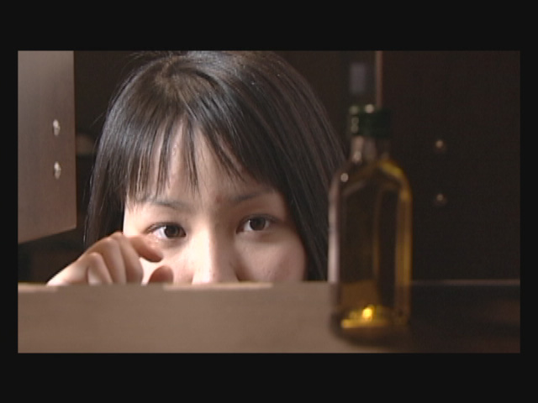 | 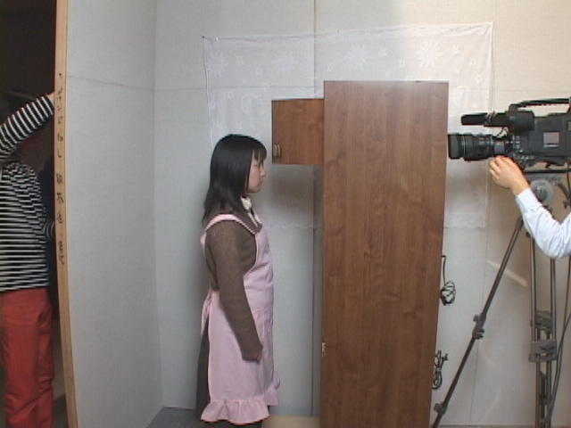 | 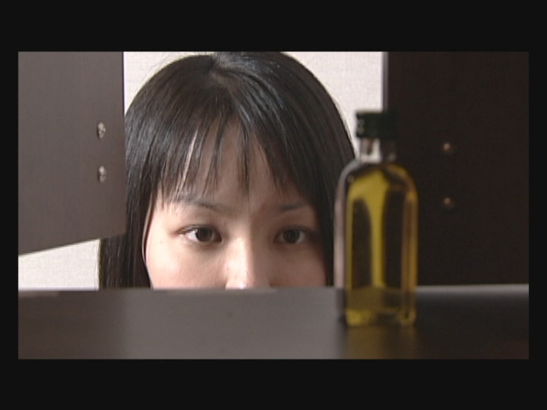
fig.10.4 | fig.10.5 | fig.10.6

#11 Moving by a crane.
Scene of a drama – camera is moved down by a crane. (fig.11.1)
N “It is also possible to move the camera so that it can catch woman’s action at hand.”
A scene of studio-camera is placed on a crane.
N “A camera is put on a crane and its height can be changed. In this way, the position of a camera can overcome physical limitations to choose the best place for catching an expression of a film story. (fig.11.2&11.3)
This is enabled by the principle of camera ubiquity.”
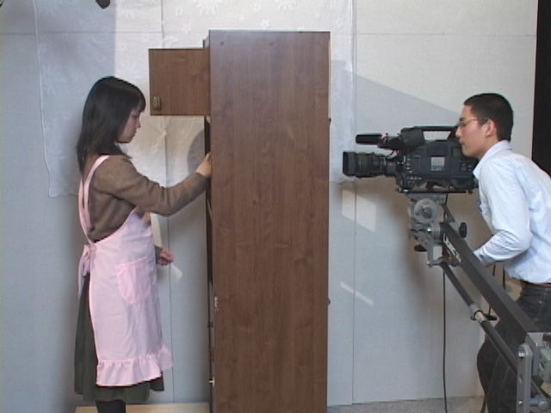 | 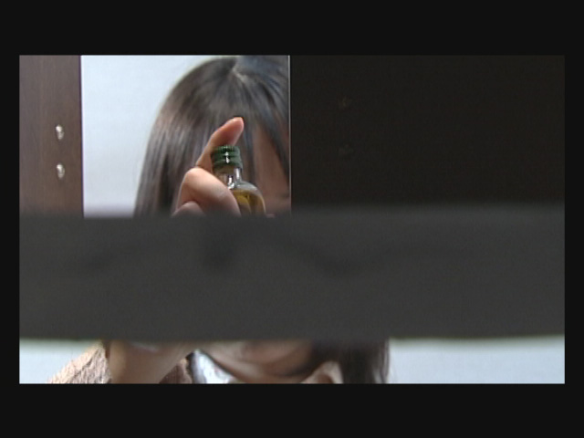 | 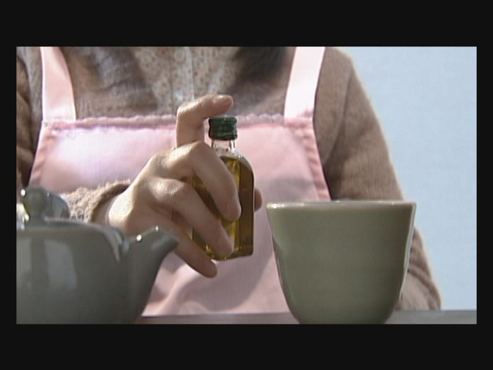
fig.11.1 | fig.11.2 | fig.11.3

#12 Expression from a low angle.
Husband’s expression is filmed from a low angle. (fig.12.1)
N “After the cut of woman’s action, lets go to insert a cut in that a man is doubtfully looking at her. It is clear that the insertion of such cut expands story’s expression. To catch man’s expression, a camera is taking him from a low position. Such composition can express one’s internal emotions.”
N “If a camera can not be placed bellow the floor, such expression can be made by rising the position of a person. This is also an example of the application of camera ubiquity principle.”
(fig.12.2)
N “Thus, the use of camera ubiquity principle enables appropriate audio-visual expression and also expands the possibilities of such expression.”
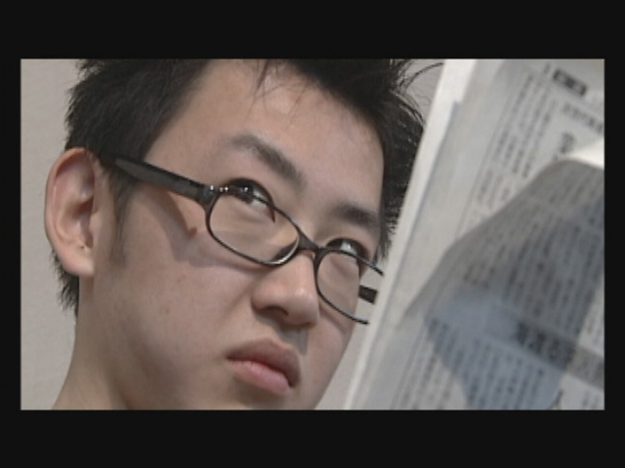 | 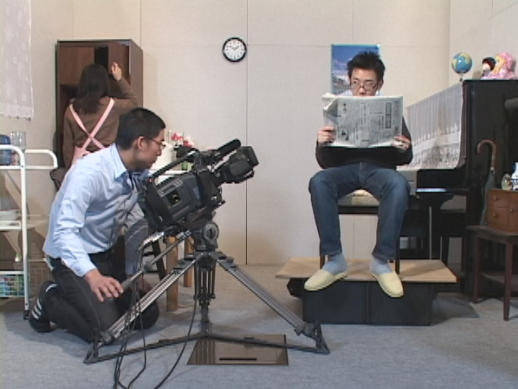
fig.12.1 | fig.12.2

#13 Expression using a dolly.
Wife’s confession – camera is working when simultaneously turning.
N “In real audio-visual expression, a camera is sometimes turning to find out what is the best angle to make the story better to be understood.”
A scene of filming with a dolly. (fig.13.1～13.3)
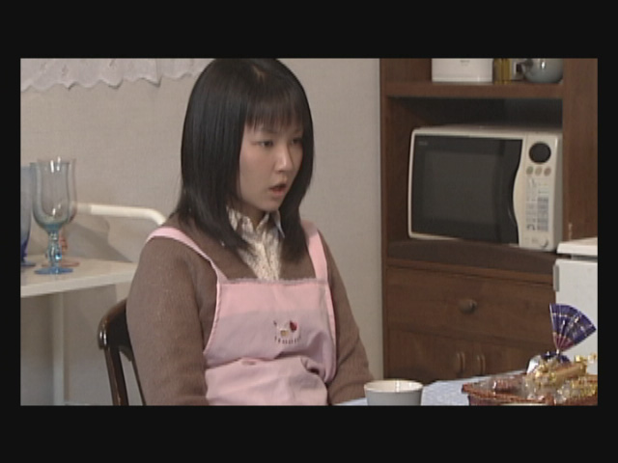 | 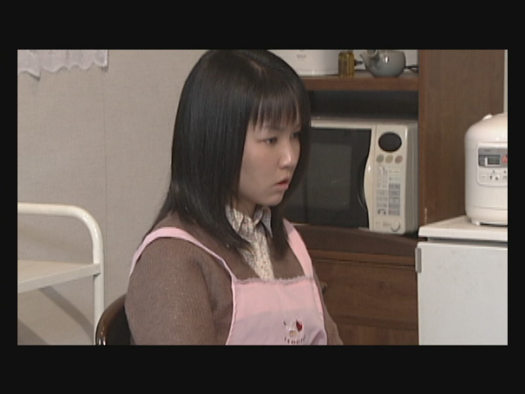 | 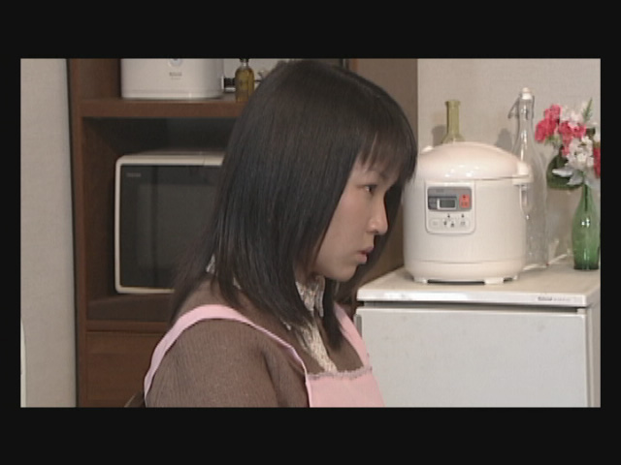
fig.13.1 | fig.13.2 | fig.13.3

N “If staff is cooperating and uses such moving machine, the effect of audio-visual expression is getting more impressive.” (fig.13.4&13.5)
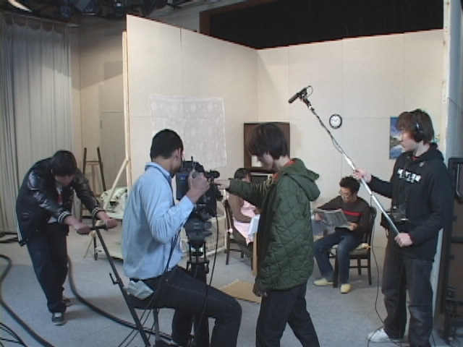 | 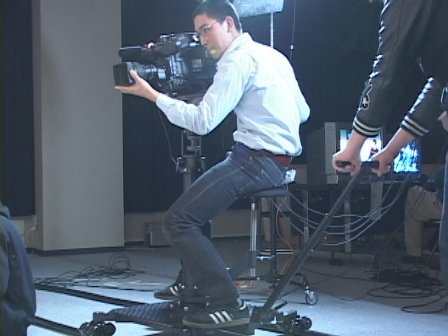
fig.13.4 | fig.13.5

#14 Summary.
N “It is clear that the position as well as moving of a camera is very important for the expression of a film story. When thinking about audio-visual expression, it is necessary to understand well the concept of camera ubiquity.”

